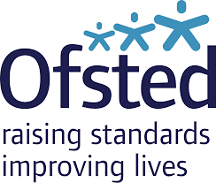

**Congratulations to Wycombe Hospital Nursery team on successful Ofsted**

A huge well done to the Wycombe Hospital Nursery Team who in March 2022 received a “good” overall from a recent Ofsted inspection.

All 4 areas – the quality of education; behaviour and attitudes; personal development; leadership and management – were assessed as "good".

The report notes that “children are happy and feel safe in this close-knit family-orientated nursery. Babies have a wonderful time. Young children who speak English as an additional language feel settled. Staff support children with special educational needs and/or disabilities well. Staff have good knowledge of the children’s needs.  Children make good progress in their development”.

The report notes too that “staff have worked incredibly hard during the COVID-19 pandemic. The nursery remained open throughout all lockdowns and parents comment on the dedicated staff team.”